INFS 3200 : Practice Two

Name : Peng Yu

Student ID : 46635884

TASK 1

Map the cube

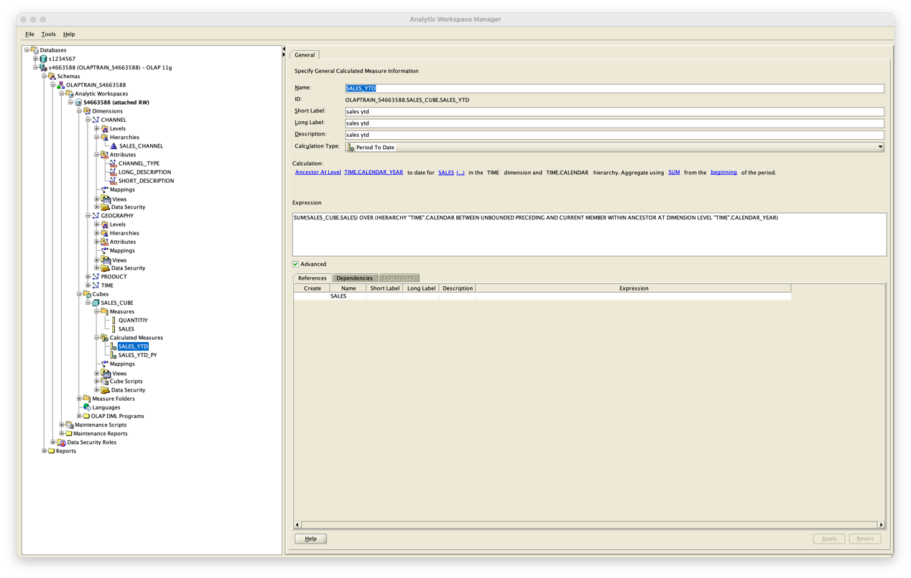

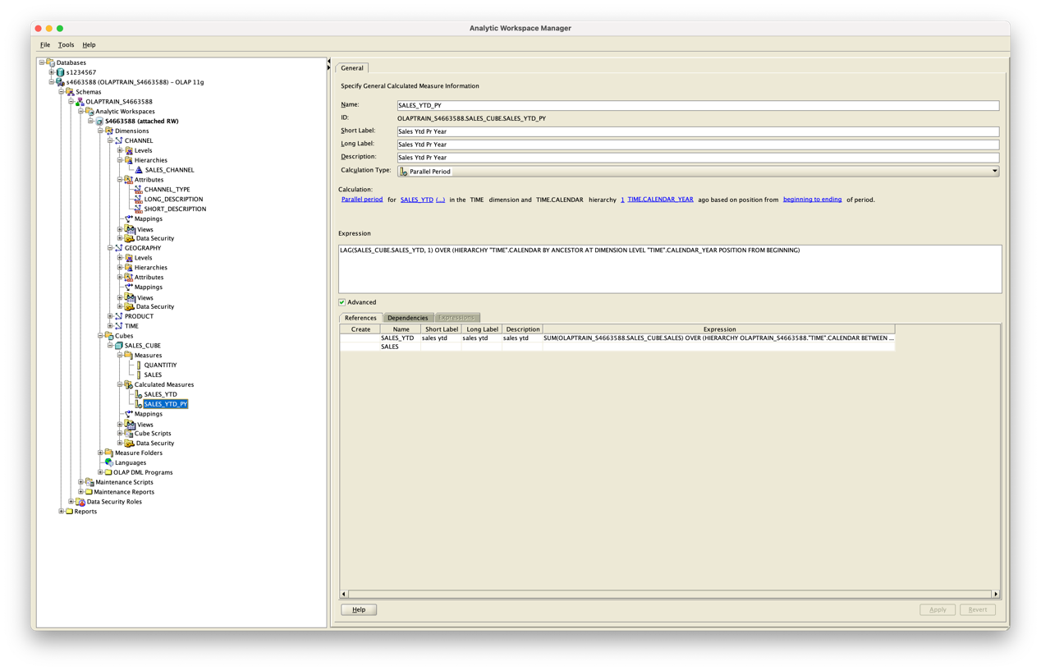

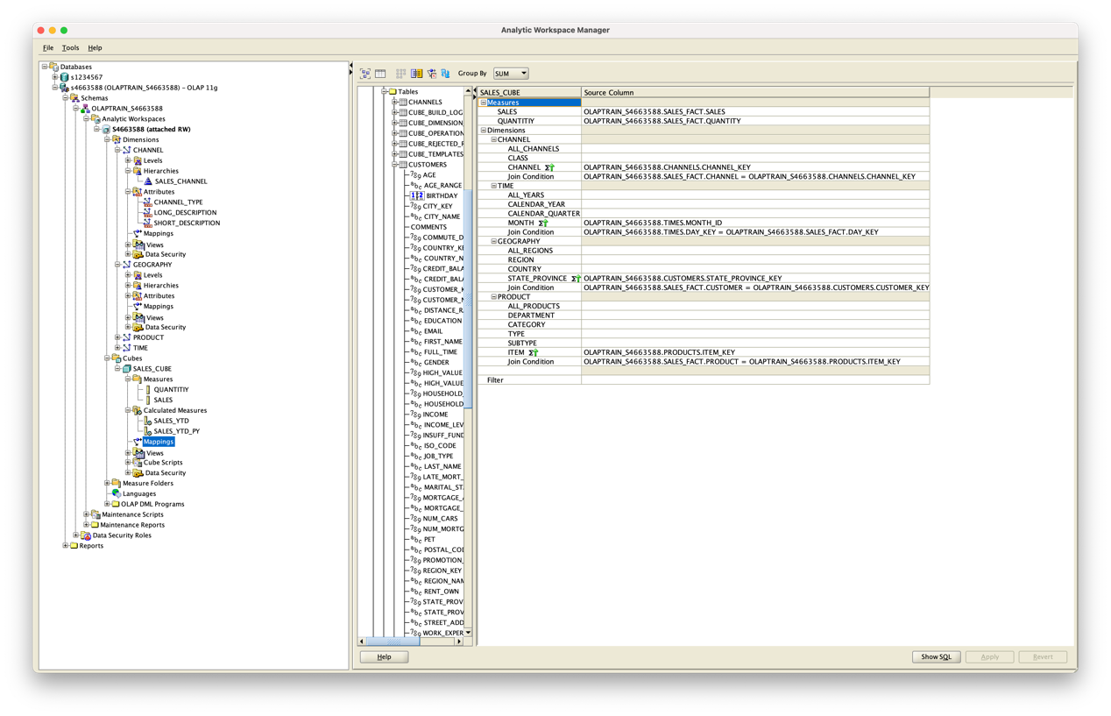

TAKS 2

Maintain the cube

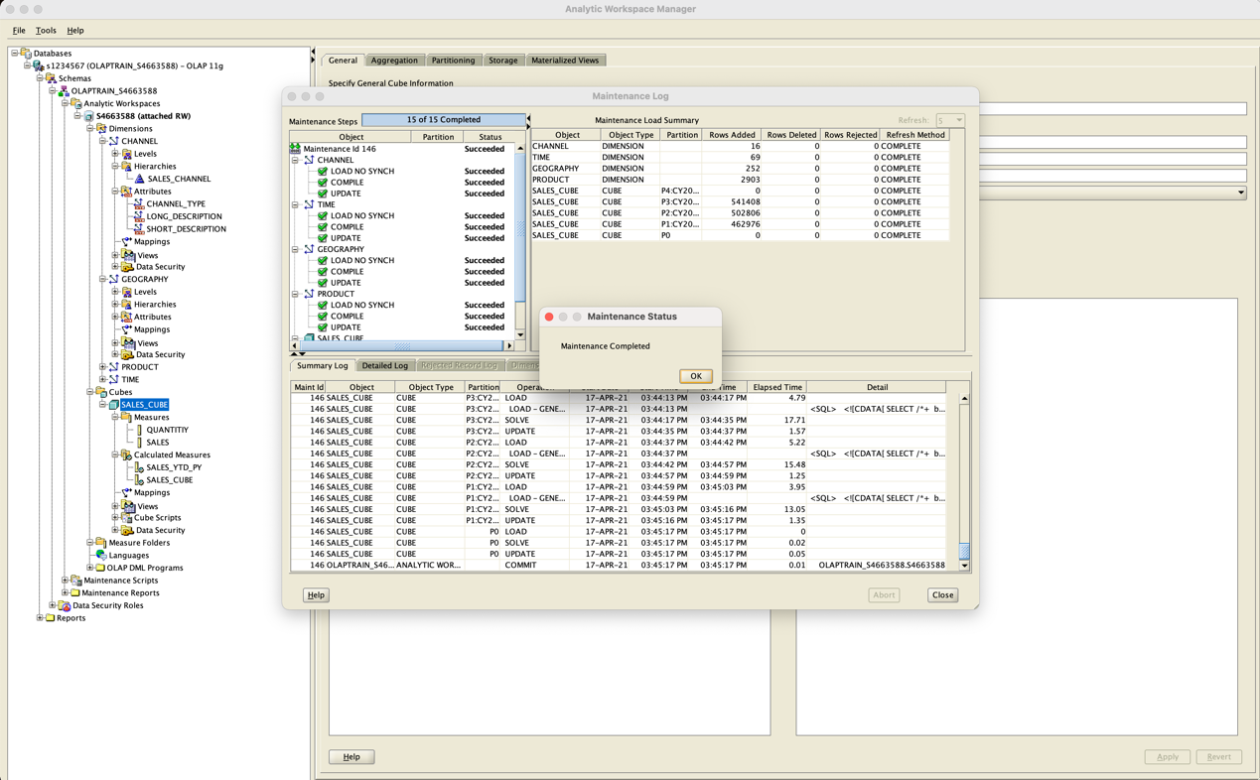

TASK 3

(A)

Roll-up

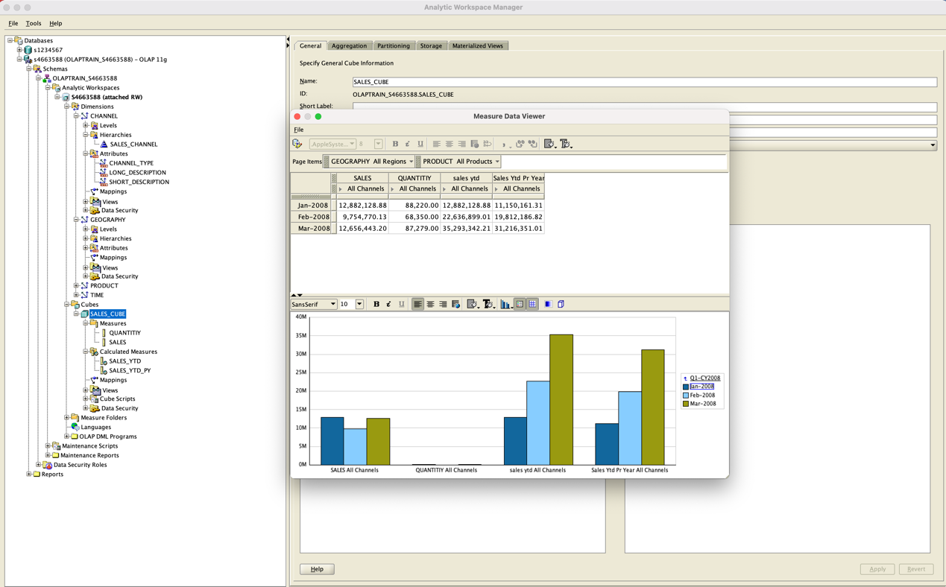

The figure above shows the data from January to March in the Q1-CY2008. Now we do the roll-up, the level should be Q1-CY2008 --> CY2008 --> All Years.

Results:

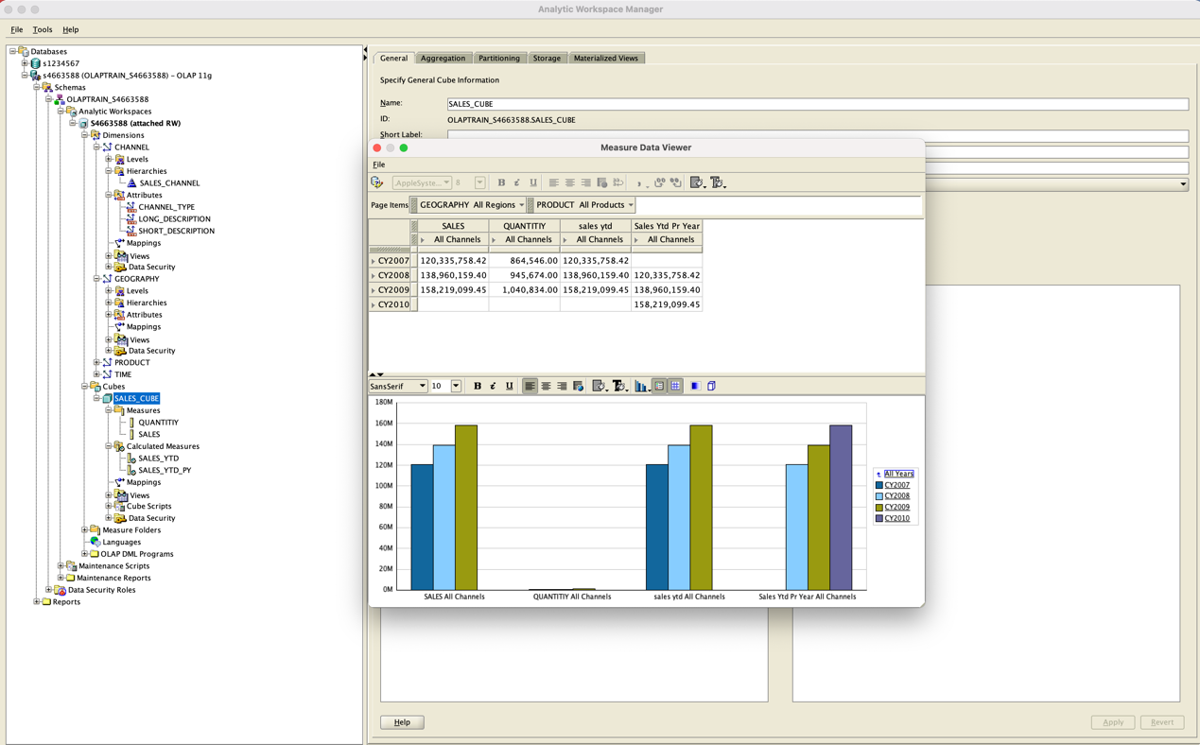

Drill-down

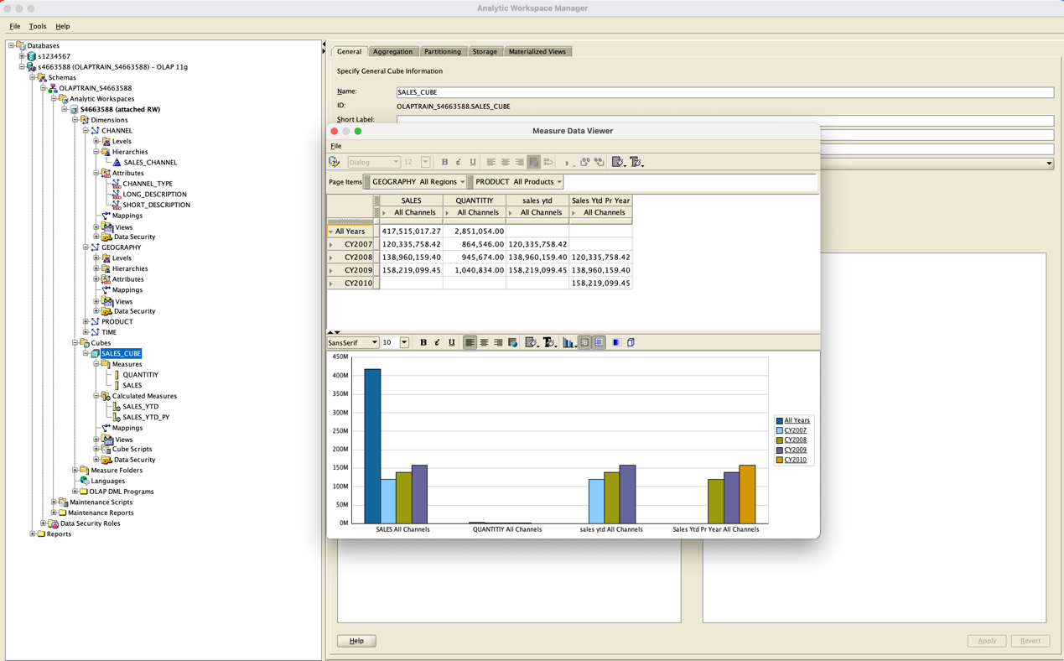

The figure above shows the data from CY2007 to CY2010 in the All Years. Now we do the drill-down, the level should be All Years --> CY2007 --> Q1-CY2007.

Result:

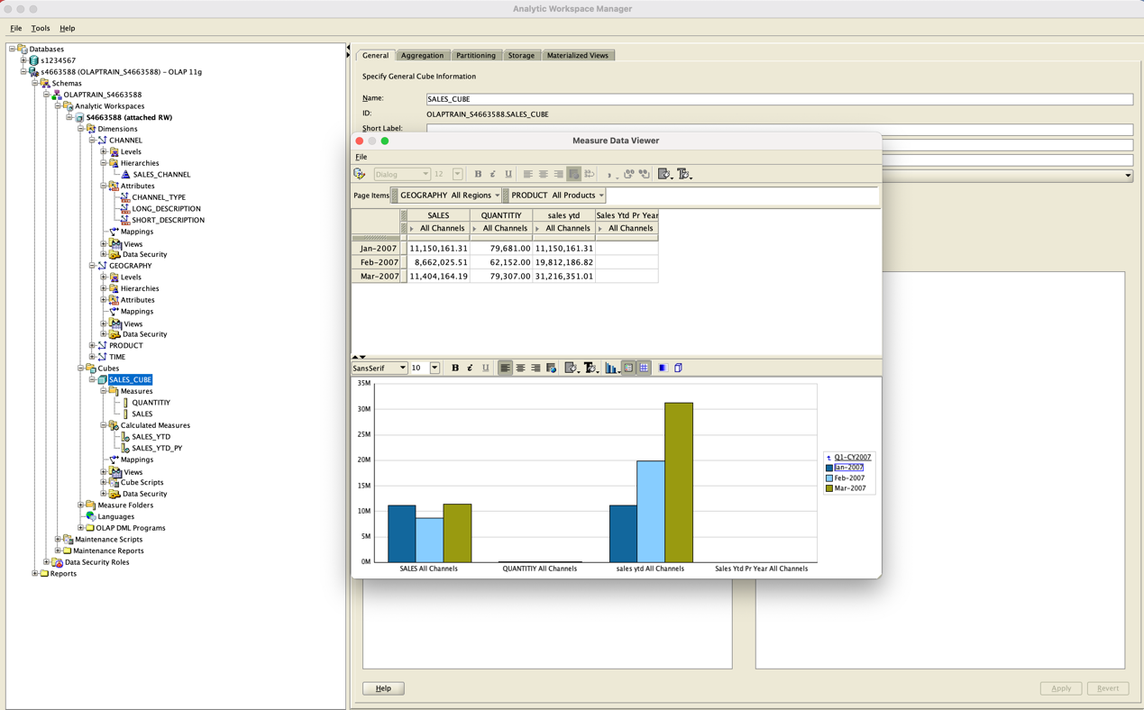

Pivot

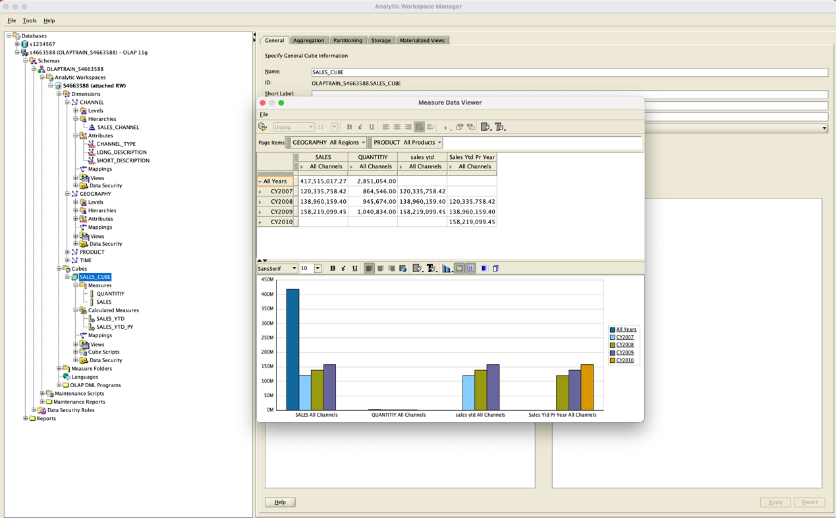

The dimensions in the figure above are All Years and All Channels data. Then we rotate the cube and get data on All Products and All Channels.

Result:

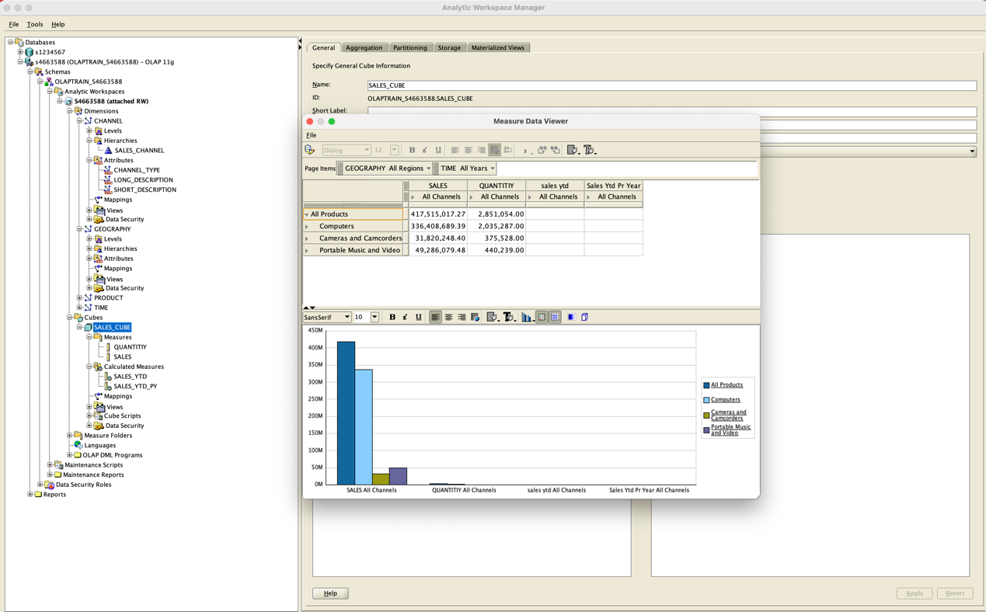

(b)

(1)

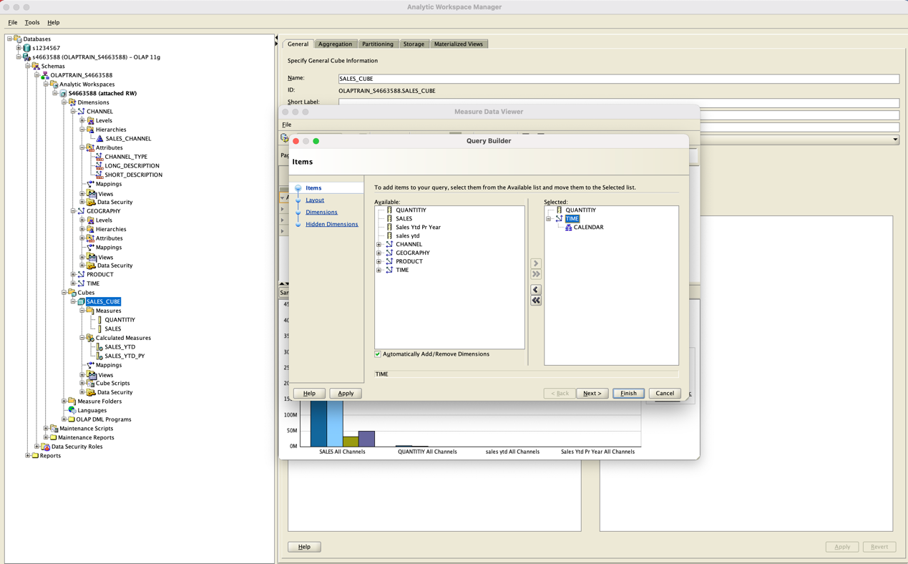

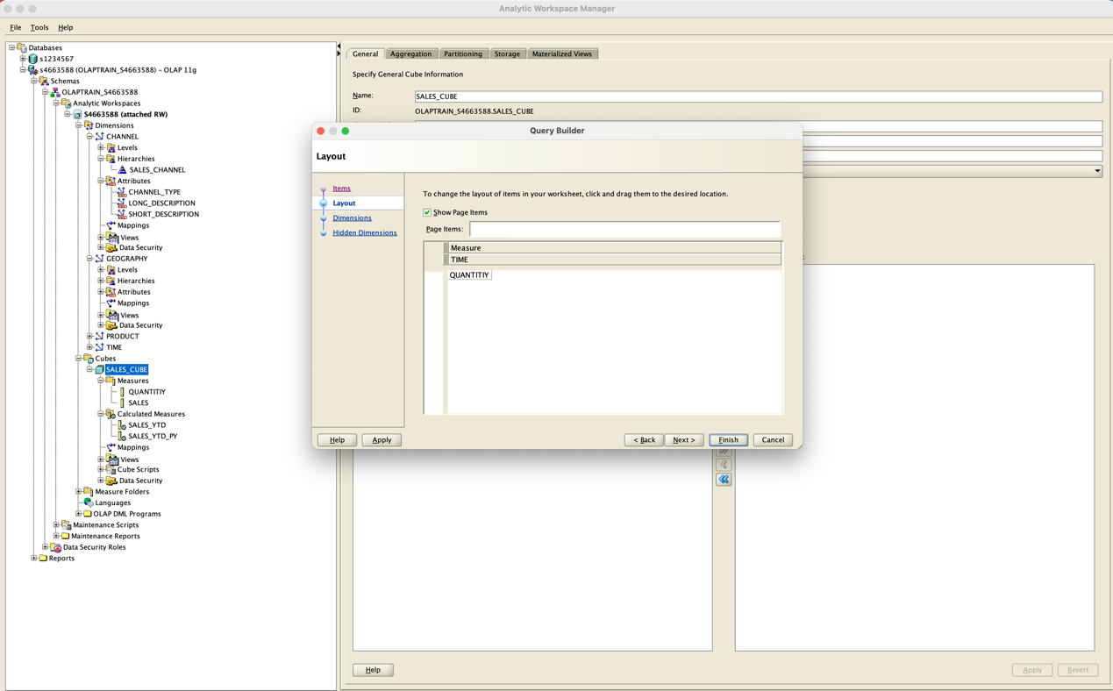

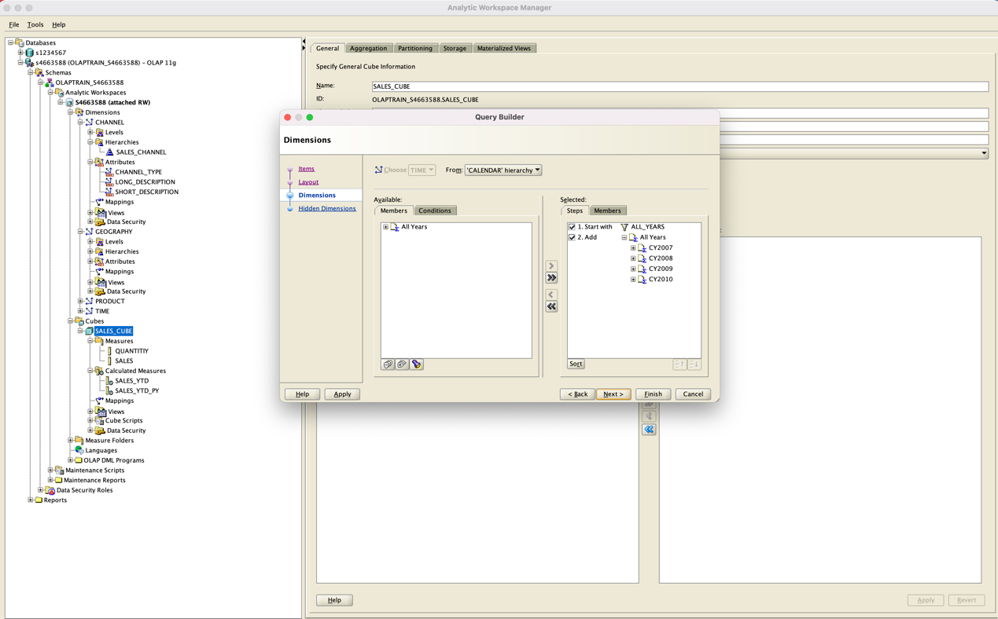

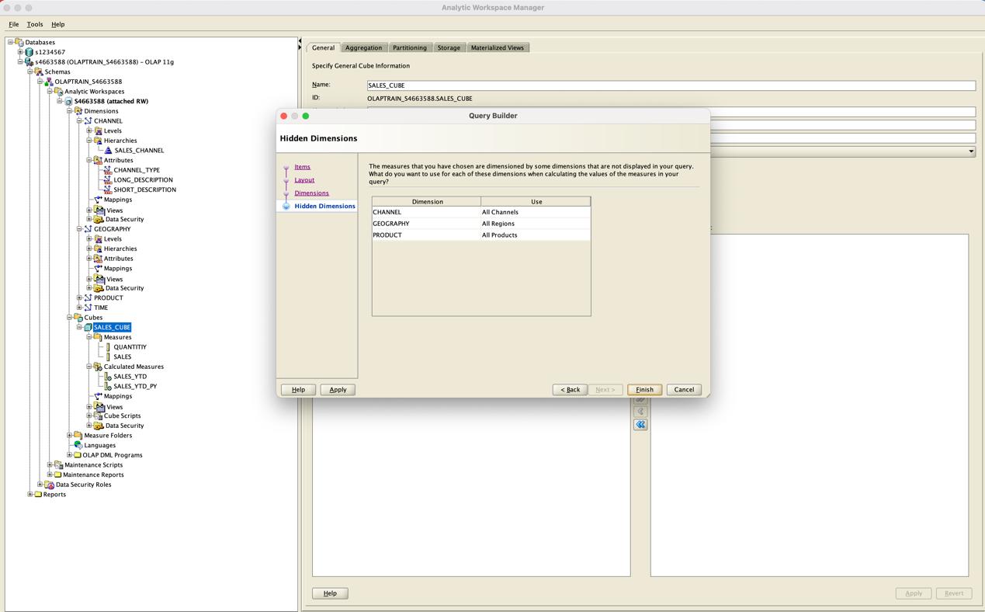

Result for first view

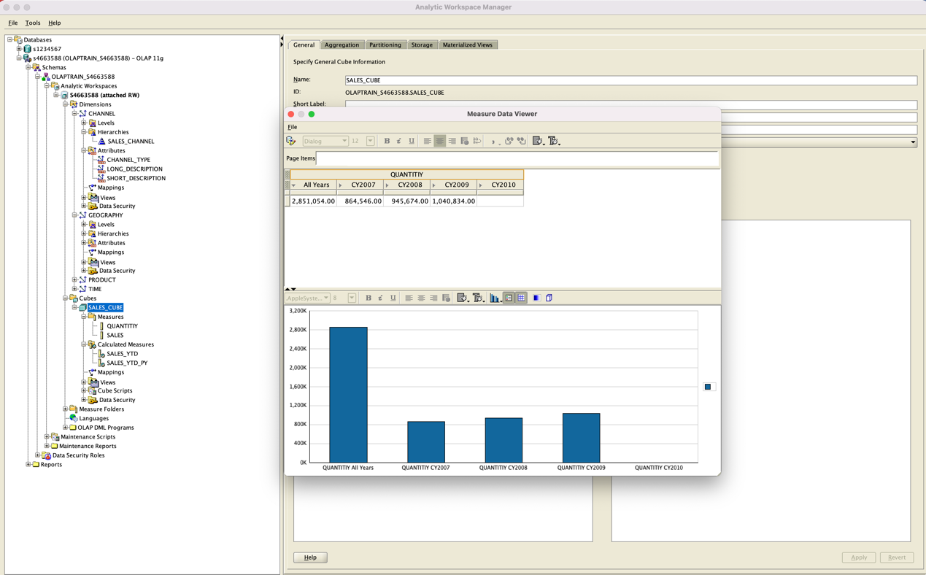

(2)

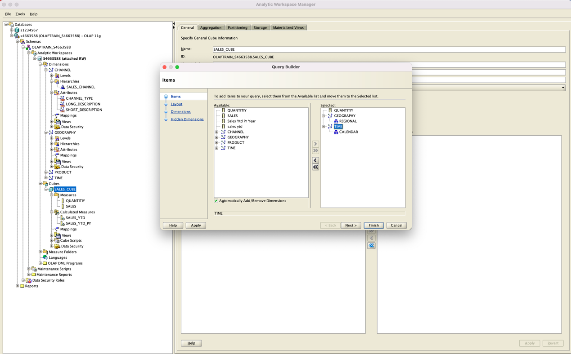

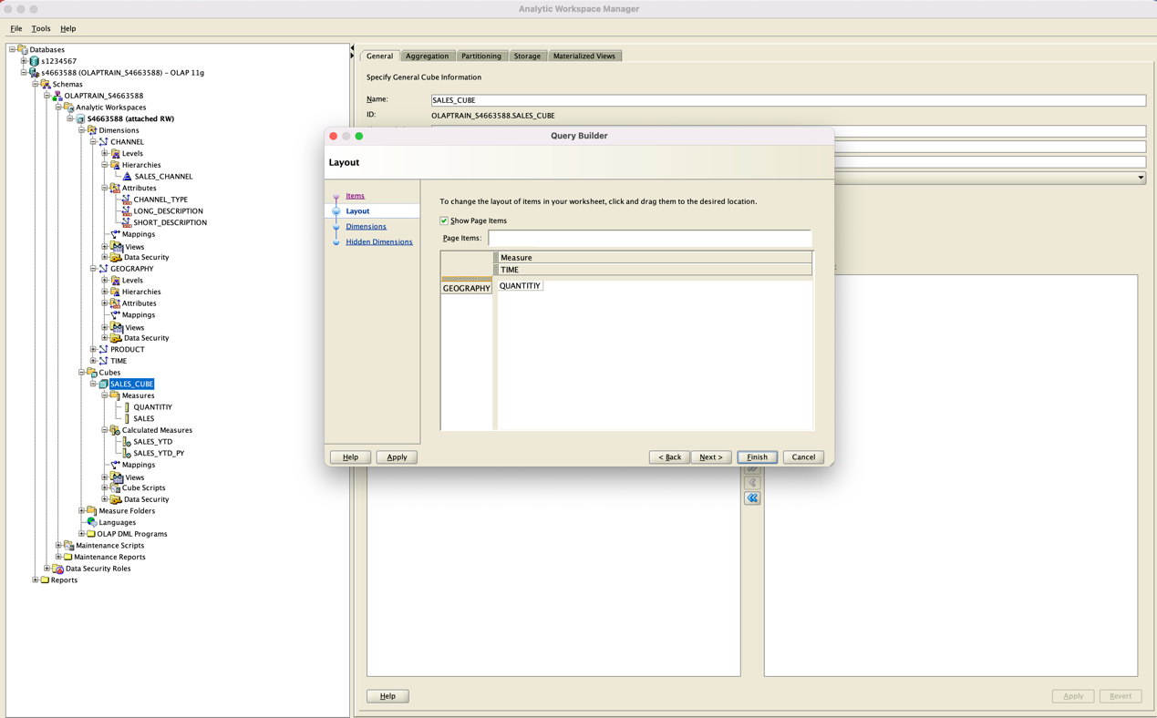

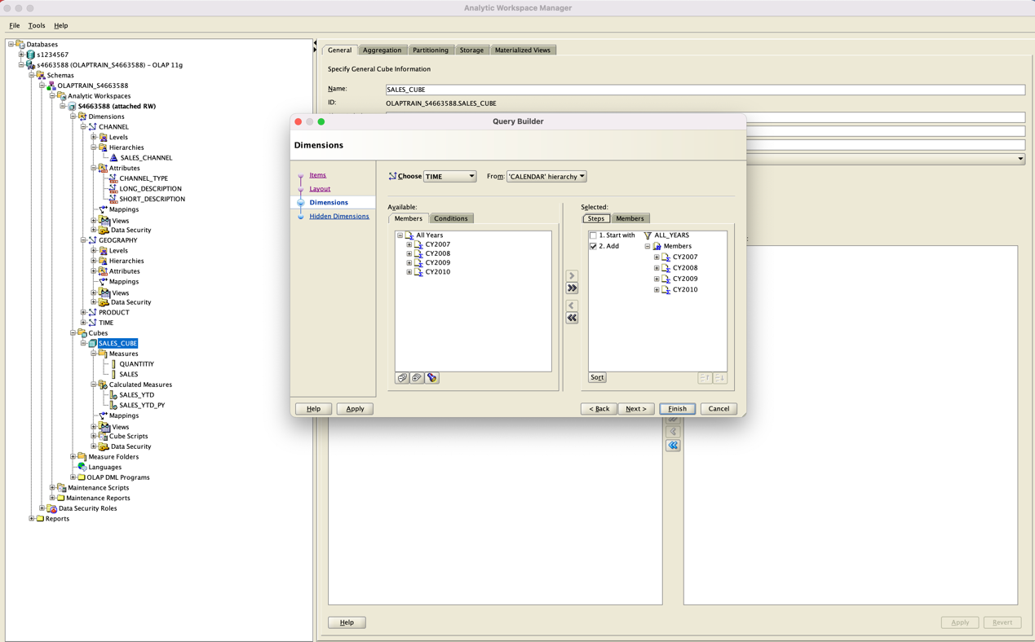

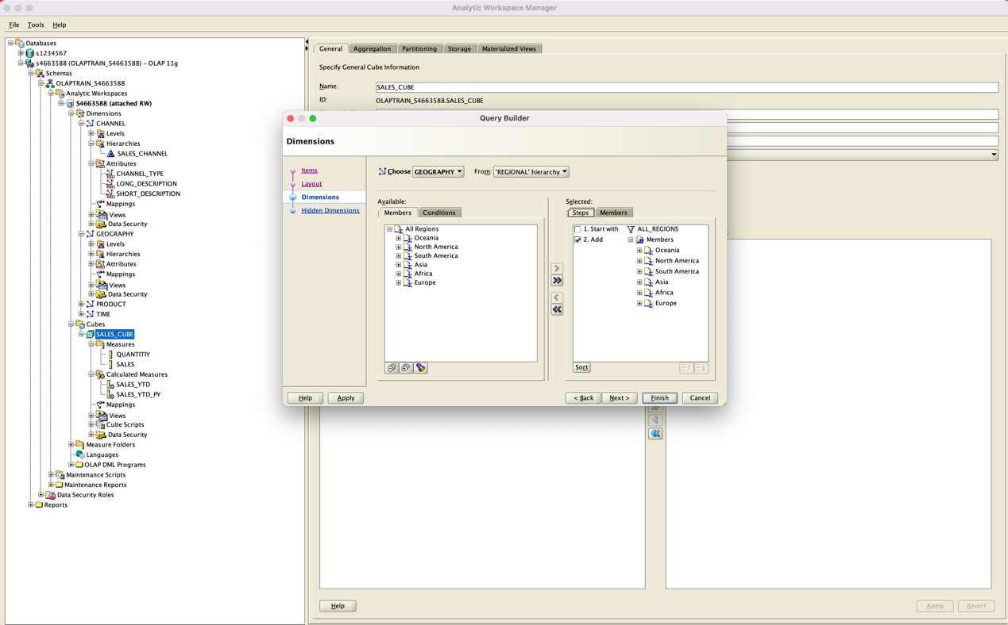

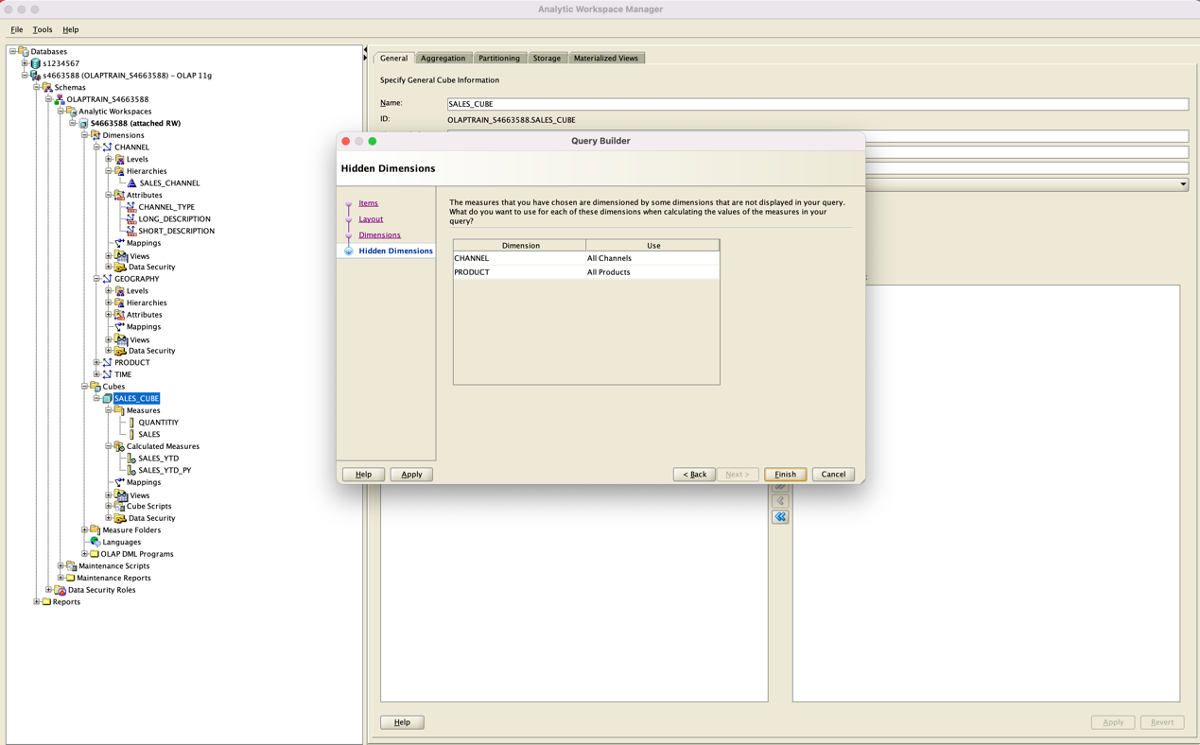

Result for second view

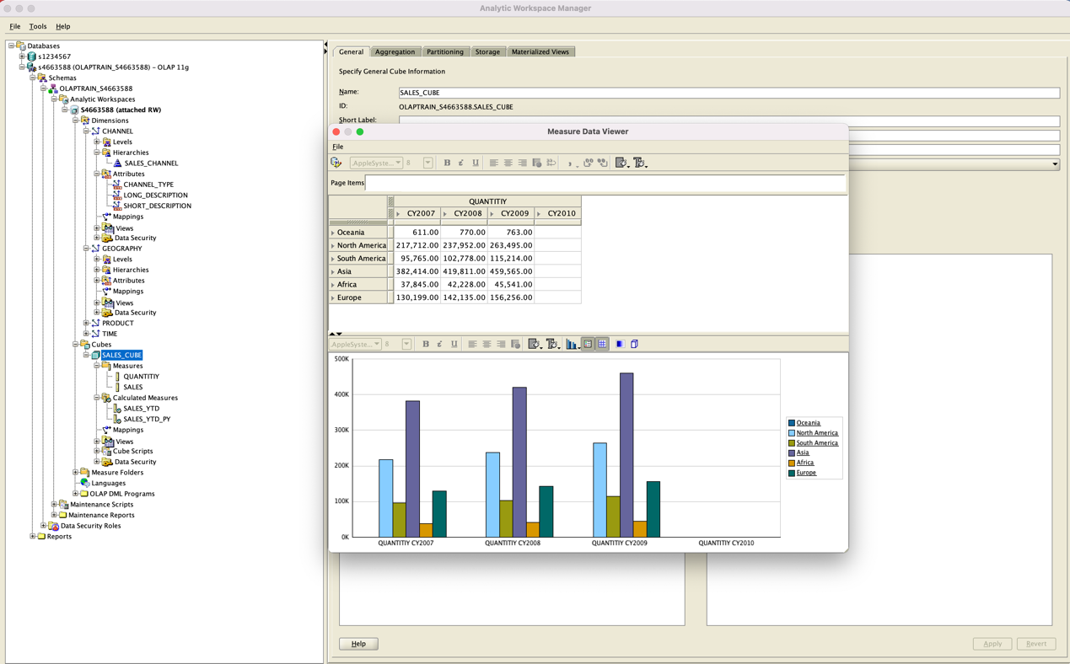

TASK 4

SELECT c.class_short_description AS class,

p.department_long_descript AS dept,

t.calendar_quarter_long_de AS qtr,

ROUND(s.sales) AS sales

FROM PRODUCT_STANDARD_VIEW p,

SALES_CUBE_VIEW s,

CHANNEL_SALES_CHANNEL_VIEW c,

TIME_CALENDAR_VIEW t,

GEOGRAPHY_REGIONAL_VIEW g

WHERE (c.DIM_KEY = s.CHANNEL AND

g.DIM_KEY = s.GEOGRAPHY AND

p.dim_key = s.product AND

t.DIM_KEY = s.TIME AND

c.LEVEL_NAME = 'CLASS' AND

p.LEVEL_NAME = 'DEPARTMENT' AND

s.geography = 'ALL_REGIONS' AND

t.LEVEL_NAME = 'CALENDAR_QUARTER' AND

t.CALENDAR_YEAR = 'CY2009')

ORDER BY class, dept, qtr;

